

NEWS MAVENS



**Submitted By**:

Usama Shafique

(F-201054)

Rameen Naveed

(F-201043)

Asjad Ullah

(F-201016)

**Supervisor:**

**Engr** Fahim Muhammad Khan

**SE Cordinator**

DEPARTMENT OF SOFTWARE ENGINEERING

ARMY PUBLIC COLLEGE OF MANAGEMENT AND SCIENCES

AFFILIATED WITH THE UNIVERSITY OF ENGINEERING AND TECHNOLOGY

TAXILA

December13,2022News Mavens

A thesis submitted in partial fulfillment of the requirements for the degree of

B.Sc. Software Engineering

**Authors**

Usama Shafique (F-201054)

Rameen Naveed (F-201043)

Asjad Ullah (F-201016)

**____________________________________**

**Supervised by**

**Engr** Fahim Muhammad Khan

**SE Cordinator**

_________________________

Head of Department

Dr. Huma Hayyat Khan

DEPARTMENT OF SOFTWARE ENGINEERING

ARMY PUBLIC COLLEGE OF MANAGEMENT AND SCIENCES

**December13,2022**

**ACKNOWLEDGEMENT**

We would like to express our sincere gratitude to**………………………………**

**UNDERTAKING**

This is to declare that the project titled “Title of your FYP” is an original work done by the undersigned, in partial fulfillment of the requirements for the degree “B.Sc. Software Engineering” at Software Engineering Department, Army Public College of Management and Sciences, affiliated with UET Taxila, Pakistan. The work has not been presented elsewhere for assessment. Where material has been used from other sources, it has been properly acknowledged/referred.

Usama Shafique (F-201054)

Rameen Naveed (F-201043)

Asjad Ullah (F-201016)

**CERTIFICATE**

This is to certify that the project titled “News Mavens” is the bonafide work carried out by Usama Shafique,Rameen Naveed,Asjad Ullah, students of BSc. Software Engineering, of Army Public College of Management and Sciences, affiliated with UET Taxila during the academic year 2018-2021, in partial fulfillment of the requirements for the award of the degree of BSc. Software Engineering and the project has not formed the basis for the award previously of any other degree, diploma, fellowship, or any other similar title.

Date: Signature of the Supervisor

December13,2022

**ABSTRACT**

**News Mavens**

NewsMavens will be the best platform for everyone to stay up to date on daily news reports, and a large community of journalists can take advantage of our platform by sharing their news in various forms and writing blogs to build their profile, and as their news trended, they will be paid (via CPV, CPM) for it.Many large companies or media houses will be able to hire journalists on a remote basis through our platform (small projects, contract basis). It will also assist large media organizations in providing the remote journalists they require based on the journalist's profile. It will save them time from going through the lengthy process of hiring the right person in their area.They can hire an expert from any region and work with him remotely using NewsMavens. It will provide them with a large network of journalists from which to choose. Our platform will provide a good communication channel, payment security, and protection for both the work of journalists and the projects of buyers. The media companies can also post jobs on NewsMavens for journalists to bid on.

**Keywords:**

**LIST OF FIGURES**

**Table of Contents**

1. Introduction 1

1.1. Problem Statement 1

1.2. Aim and Objectives 1

1.3. Application/Utilization of project 1

2. Literature Review 2

2.1. Background Knowledge 3

2.2. Existing System/comparison 3

3. Methodology 3

3.1. Detailed Methodology with block and flow diagrams 4

3.2. Project time-line 7

3.3. Experimental/ Simulation Setup

3.4. Details of Work packages completed/milestones achieved

4. Result and Discussion

4.1. Evaluation parameters...................................................................................................

4.2.Simulation Result

4.3.Product Demo/ScreenShot

4.4.Result discusson

1. **Introduction:**

News Mavens will be the best platform for everyone to keep themself up to date about daily news reports and a vast community of journalists can take huge advantage of our platform as they can share their news in many forms and write blogs to make their profile strong and as their news goes on trending they will be paid (using CPV, CPM) for it. Our platform will provide remote work for journalists as many big companies or media houses can hire them on remote basis work (small projects, contract basis). It will also help big media houses to provide them with remote journalists they need according to the profile of journalists.

**1.1 Problem statement:**

* Job security is one of the most difficult aspects of being a journalist these days.
* People nowadays rely on unauthenticated social media news that lacks a reliable source.
* Also, because of the market gap, media companies are unable to find the right person.
* Many news organizations require journalists for single projects but must hire them because there is no proper channel for hiring journalists for single projects remotely or on-site.

**1.2. Aim and objectives:Aim:**

To facilitate journalists/viewer’s to see updated jobs/new’s.

**Objectives:**

To Help the Journalists community to find freelance remote work opportunities and to reduce the Job insecurity for journalists.

**1.3. Application/utilization of research:**

The work done on mobile journalism and digitalized journalism, we concluded our idea that news mavens can fill the gap left in them. As we know everything is almost getting digitalized and has strong existence on the internet so we thought why not a platform for journalists which can help them do their job from anywhere, a platform to help media organizations, and news agencies to get news reports from a remote journalist from a place where they cannot send their person immediately. Also, our platform will help users to get every kind of news just a single tap away in form of a mobile app on their phones. Also, we have noticed the communication and wages gap in the news industry our platform will make sure to provide both ends journalists, news agencies and organization to have a better and modernized way of communication through our platform so they can end on better terms for their tasks or projects.

1. **Literature Review:**

When viewed historically, modern citizens have incomparable opportunity to receive and participate in news reporting.[1]

The main goal of the MoJo(Mobile Journalist )MATE platform is to improve the quality of mojo stories and implement the complete workflow of a newsroom, working within this framework is expected to improve users’ new media capabilities.[2]

The app must be integrated sufficiently in a broader social media strategy. In other words, the innovation must supported by every stakeholder of the regional news station.There must be invested in a platform, in an embedding in the editorial structure of the regional news broadcaster and in interaction between the broadcaster and the youngster. Young people want to know what will happen to the content they deliver through the mobile reporting application. Additionally, an incentive policy can be set up to motivate users submitting news items repeatedly[3].

The work done on mobile journalism and digitalized journalism, we concluded our idea that news mavens can fill the gap left in them. As we know everything is almost getting digitalized and has strong existence on the internet so we thought why not a platform for journalists which can help them do their job from anywhere, a platform to help media organizations, and news agencies to get news reports from a remote journalist from a place where they cannot send their person immediately. Also, our platform will help users to get every kind of news just a single tap away in form of a mobile app on their phones. Also, we have noticed the communication and wages gap in the news industry our platform will make sure to provide both ends journalists, news agencies and organization to have a better and modernized way of communication through our platform so they can end on better terms for their tasks or projects and we will make sure the rates and prices are accordingly the work effort done by journalist and also keep check no one is charging more then regular prices.

**2.1 Background Knowledge:**

In the phases of economic downturn, working journalists have always been affected by downsizing, termination, and layoff and cut in salaries as well as job- related issues which are heighting job related concerns in journalists working in the media industry. [4]

Many have expressed concern about the effects of false stories ("fake news"), circulated largely through social media. [5]

From a historical perspective, contemporary citizens have gained incomparable opportunities to access and contribute to news reporting. [6]

**2.2 Existing System/Comparison:**

|  |  |  |  |
| --- | --- | --- | --- |
| Existing System | Remote | Specialized Platform | Daily Vast News Update |
| Contena | ✓ | X | X |
| JournalismJobs.com | ✓ | X | X |
| Upwork | X | X | X |
| News Mavens | ✓ | ✓ | ✓ |

**3.Methodology:**

We are using agile methodology because our project is open ended. It will require changes on daily or maybe weekly basis so for that reason we prefer agile.

1. **Concept:**

In the first phase of Agile Methodology we will determine [the scope our project](https://www.wrike.com/project-management-guide/faq/what-is-scope-in-project-management/" \t "C:\\Users\\DELL\\Desktop\\NewsMavens\\First%20Proposal%20&amp;%20Prsentation%20FYP\_blank). We will discuss key requirements with Journalists and news industries organizations and prepare documentation to outline them, including what features will be supported and proposed end results. At this stage we will also estimate the time and cost of our projects. This detailed analysis will help us to decide whether or not a project is feasible before commencing work.

1. **Inception:**

We will start the design process and create a mock-up of the user interface and build the NEWS MAVENS architecture. This stage involves further input from Journalists to fully flesh out the requirements on a diagram and determine the functionality of our application. Regular check-ins will help us to ensure that all requirements are built into the design process.

1. **Iteration:**

Next up is [the iteration phase](https://www.wrike.com/agile-guide/faq/what-is-agile-iteration/" \t "C:\\Users\\DELL\\Desktop\\NewsMavens\\First%20Proposal%20&amp;%20Prsentation%20FYP\_blank), also referred to as construction. It tends to be the longest phase as the bulk of the work is carried out here. We will work on UX design to combine all requirements of our freelance platform and all users feedback, turning the design into code. Our goal is to build the bare functionality of the project by the end of the first iteration or sprint. Additional features and tweaks can be added in later iterations. This stage is a cornerstone of Agile software development, enabling us to create working software quickly and make improvements to satisfy the user.

1. **Release:**

The product is almost ready for release. But first, we need to ensure  [quality assurance](https://www.wrike.com/project-management-guide/faq/what-is-quality-in-project-management/" \t "C:\\Users\\DELL\\Desktop\\NewsMavens\\First%20Proposal%20&amp;%20Prsentation%20FYP\_blank)  to perform some tests to ensure the project is fully functional. We will test the system to ensure the code is clean if potential bugs or defects are detected then we will address them swiftly. When all of this is complete, the project’s final iteration can then be released into production.

1. **Maintenance:**

The software will now be fully deployed and made available to users. This action moves it into the maintenance phase. During this phase, we will provide ongoing support to keep the system running smoothly and resolve any new bugs. Over time, new iterations can take place to refresh the existing application with upgrades and additional features.

**3.1 Detailed Methodology with block and flow diagram:**

**3.1.1. Flow diagram:**

1. **Buyer Flow diagram:**

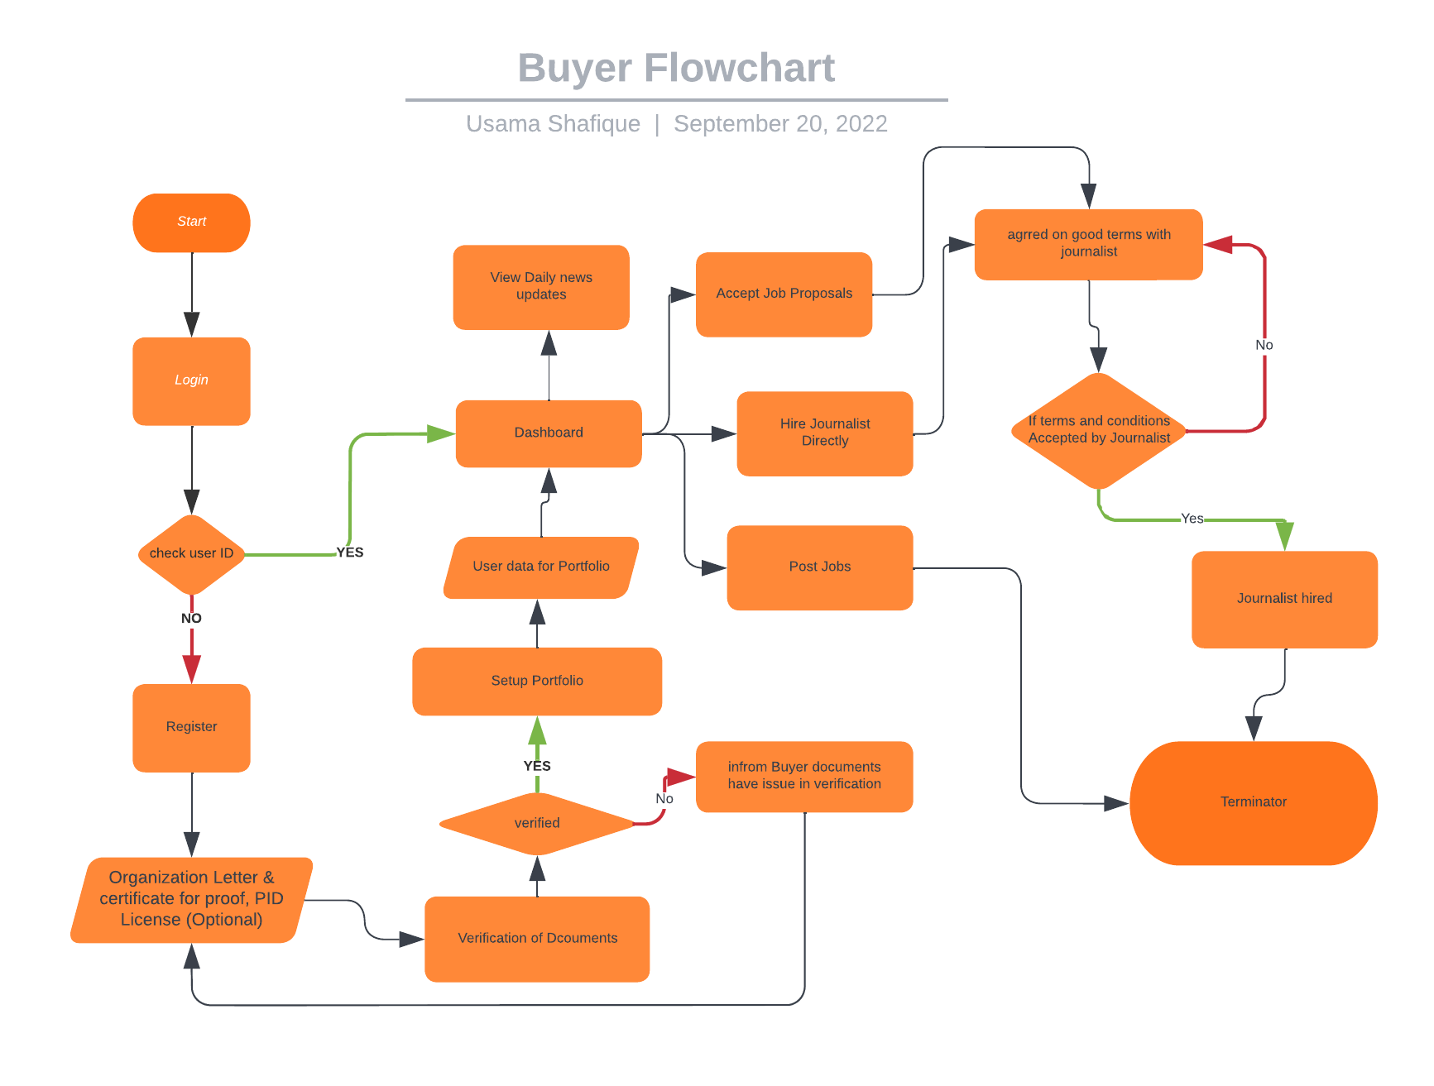

1. **Journalist Flow diagram:**

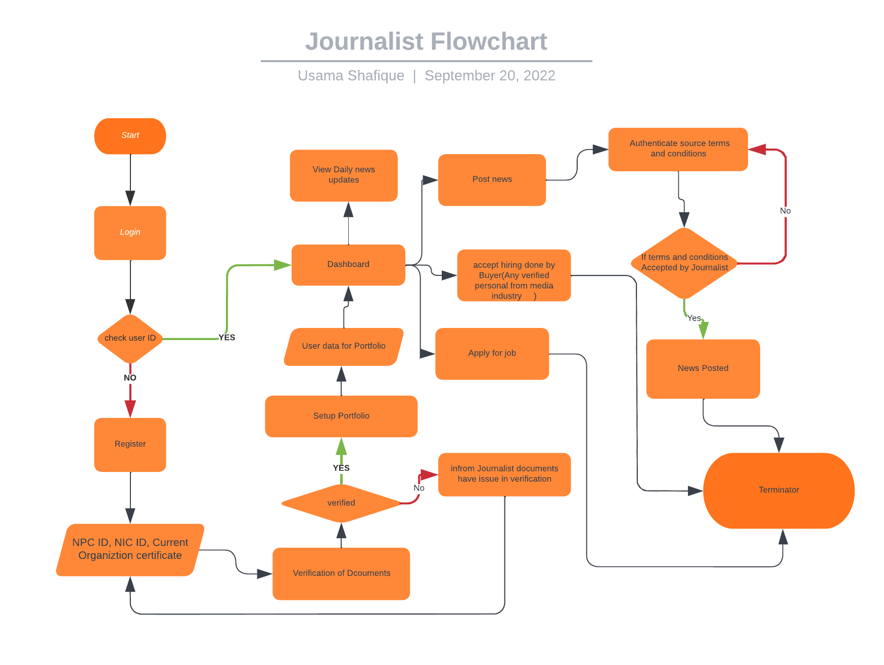

1. **Viewer Flow diagram:**

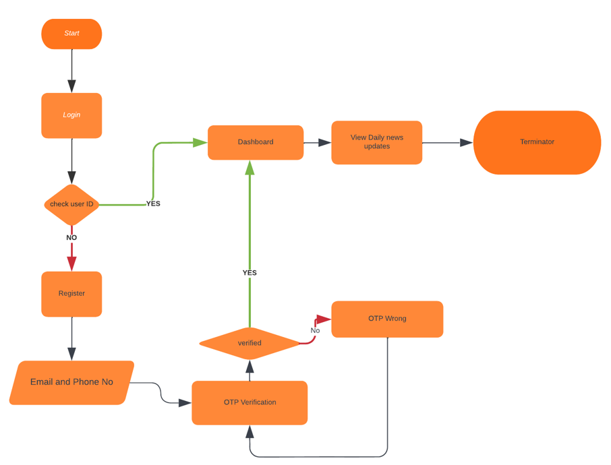

**3.1.2. Use-case Diagram:**

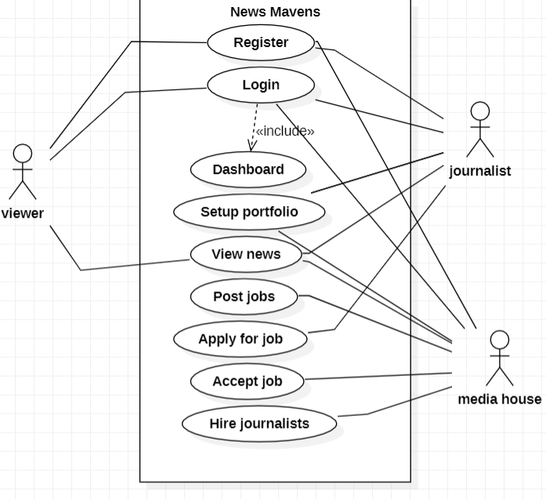

1. **Register:**

**Description:**

User register the account by entering the name,email and password.

**Actors:**

Viewer,Journalist,Media house.

**Pre condition:**

The user create the account.

**Post condition:**

The user account has been created.

**Basic flow:**

* The user (viewer,journalist,media house) enters the name, email and password.
* The user(viewer,journalist,media house) submits the name, email and password.
* The system register the name, email and password.
* The use case end.

**Alternative Flow**: (missing user name,email and password)

* The system prompts for user name,email and password.
* Use case resumes at basic(main)flow step 1

(maximum 3 attempts exceeded)

* The system displays “maximum attempts exceeded” message
* The system lock user account
* The use case ends

(invalid user email)

* The system displays “ invalid user email “ message
* The system prompts for user email.
* Use case resumes at basic flow step 1.

1. **Login:**

**Description:**

User login the account by entering the email and password.

**Actors:**

Viewer,Journalist,Media house.

**Pre condition:**

The user login the account.

**Post condition:**

The user account has been login .

**Basic flow:**

* The user (viewer,journalist,media house) enters the email and password.
* The user(viewer,journalist,media house) submits the email and password.
* The system register email and password.
* The use case end.

**Alternative Flow**: (missing user email and password)

* The system prompts for user email and password.
* Use case resumes at basic(main)flow step 2

(maximum 3 attempts exceeded)

* The system displays “maximum attempts exceeded” message
* The system lock user account
* The use case ends

(invalid user email,password)

* The system displays “ invalid user email or password“ message
* The system prompts for user email and password
* Use case resumes at basic flow step 2

1. **Dashboard:**

**Description:**

User login the account by entering the name,email and password.And open the dashboard.

**Actors:**

Viewer,Journalist,Media house.

**Pre condition:**

The user open the dashboard.

**Post condition:**

The user select either he is journalist,viewer or member media house.Then open the portfolio accordingly.

**Basic flow:**

* The user Login their account.
* The system enter user into dashboard.
* The use case end.

**Alternative Flow**: (missing user email and password)

* The system prompts for user email and password.
* Use case resumes at basic(main)flow step 2

(invalid user email and password)

* The system displays “ invalid user email and password “ message
* The system prompts for user account.
* Use case resumes at basic flow step 2.

1. **Set portfolio:**

**Description:**

User login the account by entering the name,email and password.And open the dashboard.

**Actors:**

Journalist,Media house.

**Pre condition:**

The user open the portfolio.

**Post condition:**

The user select either he is journalist,viewer or member media house.Then open the portfolio accordingly.

**Basic flow:**

* The user open the portfolio.
* The user select the category.
* The use case end.

**Alternative Flow**: (user already exsist in the portfolio )

* The system display an error message. “you already exsist”Use case resumes at basic(main)flow step 4.

1. **View news:**

**Description:**

User open the dashboard.User view the news.

**Actors:**

Viewer,Journalist,Media house.

**Pre condition:**

The user open the dashboard of news.

**Post condition:**

The user view the news

**Basic flow:**

* The user open the dashboard of news.
* The user view the news.
* The use case end.

**Alternative Flow**: (user open the another dashboard )

* The system display an error message. “you open another dashboard”.
* The system prompts for view news .
* Use case resumes at basic(main)flow step 5.

(user already exists in the View news)

* The system display an error message. “you already exist”
* The system prompts for view news .
* Use case resumes at basic(main)flow step 5

1. **Post job:**

**Description:**

Members of media houses upload different category of journalist jobs on dashboard of job proposals.

**Actors:**

Media house.

**Pre condition:**

The user open the dashboard of job proposal.

**Post condition:**

The user post jobs.

**Basic flow:**

* The company open the dashboard of job proposal.
* The company upload jobs.
* The use case end.

**Alternative Flow**: (user open the another dashboard )

* The system display an error message. “you open another dashboard”.
* The system prompts for post jobs .
* Use case resumes at basic(main)flow step 6

(user already exists in the View news)

* The system display an error message. “you already exsist”
* The system prompts for post job.
* Use case resumes at basic(main)flow step 6.

1. **Apply for job:**

**Description:**

User apply for job those are posted by media houses.

**Actors:**

Media house.

**Pre condition:**

The journalists accept job proposal of company.

**Post condition:**

The journalist sign contract provided by company.

**Basic flow:**

* The journalist accept the job posted by company
* The journalist sign the contract that company provide.
* The use case end.

**Alternative Flow**: ( )

* The system prompts for apply for jobs .
* Use case resumes at basic(main)flow step 7

( )

* The system prompts apply for job.
* Use case resumes at basic(main)flow step 7.

1. **Hire journalist:**

**Description:**

The journalist accept job proposal that are posted by company . Company hire only those journalists who accept job proposals.

**Actors:**

Media house.

**Pre condition:**

The journalists sign contract by company

**Post condition:**

The company hire journalist.

**Basic flow:**

* The journalist sign the contract that company provide.
* The use case end.

**Alternative Flow**: ( )

* The system prompts for apply for jobs .
* Use case resumes at basic(main)flow step 7

( )

* The system prompts apply for job.
* Use case resumes at basic(main)flow step 7.

**3.1.3. ER- Diagram:**

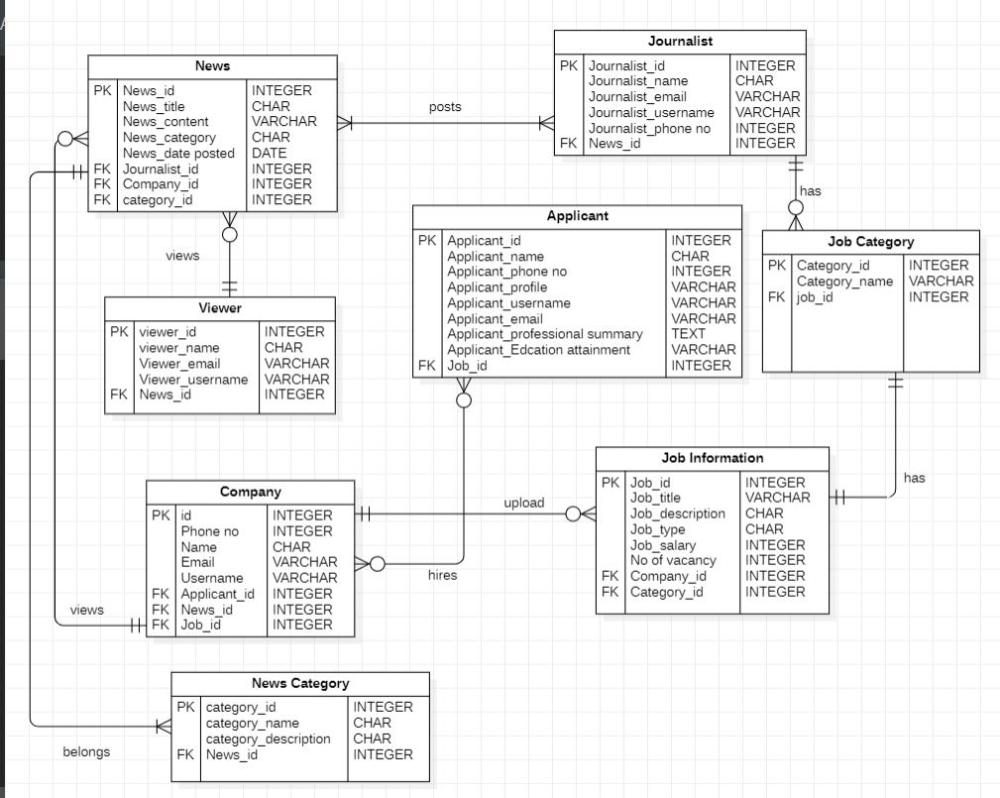

**Entities:**

* Journalist
* Viewer
* News
* Job Category
* Job Information
* Company
* Applicant

**Attributes of Entities:**

* News Entity has news_id(primary key),news title,news content,news category,news date posted, foreign key(journalists_id,company_id,category_id)
* Viewer Entity has viewer_id(primary key),viewer name,viewer email,viewer username,foreign key(news_id).
* Company Entity has company_id(primary key),company phone no, company name, company email,company username,foreign key(applicant_id,news_id,job_id).
* News category Entity has category_id(primary key),category name,category description,news_id(foreign key).
* Journalist Entity has primary key(journalist id),journalist name,journalist email,journalist username,journalist phone no,foreign key(news id).
* Applicant Entity has primary key(applicant id),applicant name,applicant phone no,applicant profile,applicant username,applicant email,applicant professional summary,applicant education attainment ,job id(foreign key).
* Job information Entity has job id(primary key),job title, job description,job type, job salary, job no of vacancy.foreign key(company id,category id).
* Job category Entity has primary key (category_id),job category name,foreign key(job id).

**Relationship:**

* Each Journalist posts one or many news .Each news is posted by one or many journalist (many to many relationship).
* Viewer views many news (1 to many relationship).
* Many company views many news(many to many).
* Many companies hires many applicants(many to many relationship).
* Company upload many job information(1 to many).
* News belongs to many news Category (1 to many relationship).
* Job information has only 1 Job Category (1 to 1 relationship).
* Journalists has many job category.(1 to many relationship).

**3.1.3. Class Diagram:**

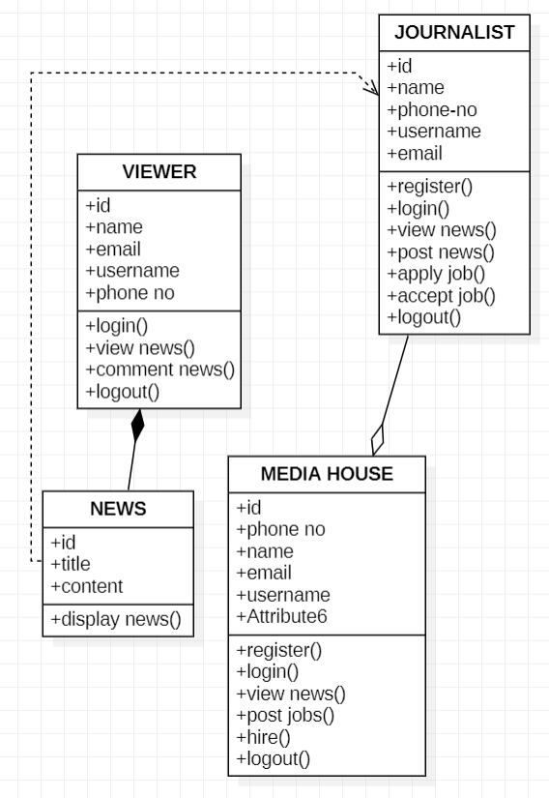

**3. 2. Project Time-line:**

Project time-line is given below.

* Collection of literature Two Weeks
* Study of Literature Two Weeks
* Analysis of Proposed Scheme One Month
* Preparation of Scheme/Model One Month
* Implementation of Scheme/Model One Month
* Analysis and Simulation One Month
* Result Formulation Two Weeks
* Final Write-up & Thesis Submission Two Weeks

1. **3. Experimental /Simulation Setup:**

**3.3.1. Frontend**

HTML

CSS

JS

Bootstrap

React

React Native

**3.3.2. Backend**

ExpressJS

NodeJS

**3.3.3. Server**

Firebase

Cloudflare Server

Cloudflare CDN

Nginx

**3.3.4. Testing Tool**

Appium

WebLoad

**3.3.5. SEO Tool**

Google Analytics

**3.4. Detail of work packages completed/milestone achieved:**

1. **Result and Discussion:**
   1. **Evaluation parameters:**
   2. **Simulation Result:**
   3. **Product Demo/ScreenShot:**

**References:**

1. Westlund, O. (2013). Mobile news: A review and model of journalism in an age of mobile media. *Digital journalism*, *1*(1), 6-26.
2. Sidiropoulos, E., Vryzas, N., Vrysis, L., Avraam, E., & Dimoulas, C. (2019). Growing media skills and know-how in situ: Technology-enhanced practices and collaborative support in mobile news-reporting. *Education Sciences*, *9*(3), 173.
3. Vandenbroucke, K., Baccarne, B., & Schuurman, D. (2014). Connecting with citizen journalists: an exploratory Living lab study on motivations for using mobile reporting applications. In *Etmaal van de communicatiewetenschappen, Proceedings*. Wageningen, The Netherlands.
4. Ashraf, A., Tayyib, M., Awais, M., & Ali, F. (2020). Effects of job insecurity on media professionals of Pakistan. Journal of Organizational Culture, Communications and Conflict, 24, 1-15.
5. Westlund, O. (2013). Mobile news: A review and model of journalism in an age of mobile media. Digital journalism, 1(1), 6-26. 3.
6. Allcott, H., & Gentzkow, M. (2017). Social media and fake news in the 2016 election. Journal of economic perspectives, 31(2), 211-36.